**PAYROLL MANAGEMENT SYSTEM**

**A Project Report submitted in Partial Fulfilment of the**

**Requirement for the Degree of**

**BACHELOR OF COMMERCE WITH COMPUTER**

**APPLICATIONS**

**Submitted by**

**V.ARUN KUMAR (C1C14675)**

**JAYAVEL CHELLAPANDI (C1C14682)**

**Under the Guidance of**

**Mrs. R. SURIYAKALA, M.Sc., M.Phil., B.Ed.,**

**LECTUREIN B.COM (CA) DEPARTMENT**

**Assistant Professor in Department of B. Com (CA)**



**DEPARTMENT OF COMMERCE WITH COMPUTER**

**APPLICATIONS**

**P.K.N ARTS & SCIENCE COLLEGE**

**(Affiliated to Madurai Kamaraj University)**

**THIRUMANGALAM**

**MADURAI DISTRICT**

**APRIL 2024**

**P.K.N, ARTS & SCIENCE COLLEGE**

**(Affiliated to Madurai Kamaraj University)**

**TIRUMANGALAM – 625706**



**BONAFIDE CERTIFICATE**

This is to certify that the project report entitled **“PAYROLL MANAGEMENT SYSTEM” is** a bonafide work done by **V. ARUNKUMAR (C1C14675), JAYAVEL CHELLAPANDI (C1C14682)** and it is submitted in partial fulfilment of the requirements for the award of the degree of **BACHELOR OF COMMERCE WITH COMPUTER APPLICATIONS** of Madurai Kamaraj University, Madurai.

**(Mrs. R. SURIYAKALA) (Mrs. Dr. B. INDRA)**

**FACULTY GUIDE HEAD OF THE DEPARTMENT**

**Place: Tirumangalam**

**Date:**

Submitted for Viva – Voice Examination held on _________________.

**INTERNAL EXAMINAR EXTERNAL EXAMINAR**

**V.ARUNKUMAR JAYAVEL CHELLAPANDI**

**REG.NO: C1C14675 REG.NO: C1C14682**

**DEPARTMENT OF COMMERCE WITH COMPUTER**

**APPLICATIONS**

**P.K.N ARTS & SCIENCE COLLEGE**

**THIRUMANGALAM.**



**DECLARATION**

We hereby declare that project report entitled **“PAYROLL MANAGEMENT SYSTEM”** in P.K.N. ARTS AND SCIENCE COLLEGE Tirumangalam Submitted to the Madurai Kamaraj University in partial fulfilment of the requirement for the award of **BACHELOR OF COMMERCE WITH COMPUTER APPLICATIONS** is record of original project work done by us, under the supervision & guidance of Mrs**. R. SURIYAKALA, M.Sc., M.Phil., B.Ed., DGT.,** P.K.N ARTS AND SCIENCE COLLEGE, TIRUMANGALAM.

**Place: Tirumangalam**

**Date: CANDIDATE SIGNATURE**

**ACKNOWLEDGEMENT**

First and foremost, we would like to place on record of our sincere thanks to the **Management of P.K.N ARTS & SCIENCE COLLEGE** for providing all infrastructure of this project successfully.

We thank to our respected **PRINCIPAL, Dr. R. GANESAN, M.Sc., Ph.D.,** in P.K.N ARTS AND SCIENCE COLLEGE, Thirumangalam. For this benevolence in having offered and provided all facilities and provisions to bring out his report successfully.

We thanks to our respected **H.O.D Mrs. DR. B. Indra, M. COM., M.B.A., M. Phil., Ph.D., PGDCA., B.ED., M.A., CGT.,** in P.K.N ARTS AND SCIENCE COLLESGE, Tirumangalam, to whom we extend our sincere thanks and whom advice was precious of during the course of our project.

The project work enjoyed the good offers of our internal guide **Mrs. R. SURIYAKALA, M.Sc., M.Phil., B.Ed., DGT., Assistant professor in department of commerce with computer application,** P.K.N ARTS AND SCIENCE COLLEGE, Thirumangalam, to whom we extend our sincere thanks and whom advice was precious during the course of our project.

We would like to express my thanks to **all my friends** for making me to learn a lot. We would like to share this succeed for my project with **my Parents and well-wishers.** We wish to offer my thanks to all who helps to finish the project in time.

|  |  |  |
| --- | --- | --- |
| **S.No.** | **CONTENTS** | **Page No.** |
| 1 | Synopsis |  |
| 2 | Introduction |  |
|  | 2.1 Project Description |  |
| 3 | System Requirements |  |
|  | 3.1 Hardware Requirements |  |
|  | 3.2 Software Requirements |  |
| 4 | Software Profile |  |
|  | 4.1 Microsoft Visual Basic 6.0 |  |
|  | 4.2 Microsoft Access 2007 |  |
| 5 | System Description |  |
|  | 5.1 Existing System |  |
|  | 5.2 Proposed System |  |
| 6 | System Testing |  |
| 7 | System Implementation |  |
| 8 | System Testing |  |
| 9 | Future Enhancement |  |
| 10 | Appendix |  |
|  | 10.1 Sample Source code |  |
|  | 10.2 Screenshots |  |
| 11 | Conclusion |  |

**PAYROLL MANAGEMENT SYSTEM**

**CHAPTER-1**

**SYNOPSIS**

**Objective:**

The primary objective of this project is to develop a comprehensive Payroll Management System designed to streamline the payroll process while providing HR with direct access to their personal and payroll information. This system aims to improve efficiency, reduce administrative burdens, ensure accuracy and compliance with tax laws, and enhance employee satisfaction.

**Scope:**

The system caters to the needs of HR departments and employees of small to medium-sized enterprises. It encompasses various modules including payroll processing, tax management, employee management, time and attendance tracking, benefits administration, performance management, and reporting analytics.

**CHAPTER-2**

**INTRODUCTION**

The Payroll Management System is a pivotal project designed to simplify and organize payroll and HR tasks for small to medium-sized enterprises. At its core, this system facilitates the efficient management of payroll processes, enabling accurate and timely handling of employee salaries, tax deductions, and benefits.

Developed using Visual Basic 6 (VB6), the project offers an intuitive interface for both administrators and employees, ensuring ease of use and accessibility. The backend, powered by Microsoft Access 2007, ensures data integrity and security. This project stands out by enhancing the communication between HR departments and employees, promoting transparency, and improving overall satisfaction without the complexity of automation.

**2.1 PROJECT DESCRIPTION**

This Payroll Management System project is designed to streamline and automate the process of paying an organization's employees. It ensures accurate salary calculations, deductions, tax withholdings, and compliance with financial regulations. The system also simplifies the management of employee details, such as hours worked, leave balances, and benefits. By integrating advanced technology and user-friendly interfaces, this project aims to enhance efficiency, reduce errors, and provide real-time access to payroll data, ultimately leading to improved operational efficiency and employee satisfaction.

**MODULES** **DESCRIPTION**

**Dashboard**

This module deals to maintain Leave applications, internal job postings and the job applications of the employees.

**Employee Information**

This module contains Employees Basic information, educational background, last work experience and bank details.

**Salary Management**

This module provides the breakdown of an employee’s net salary individually.

**Attendance management**

This module gives the information of attendance details of every employee individually.

**Reports**

This module contains employees Payroll report, leave report and basic information report.

**Support and helpdesk**

This module provides the contact details of support team for the technical assistance.

**CHAPTER-3**

**SYSTEM REQUIREMENTS**

**3.1 Hardware Requirements**

* **Processor**: Intel Core i3 or similar, 1.5 GHz or higher
* **RAM**: 4 GB minimum
* **Display**: 1024 x 768 screen resolution minimum
* **Network Interface**: 100 Mbps Ethernet or Wi-Fi connectivity
* **Operating System**: Should be compatible with Microsoft Access 2007, which typically includes Windows versions from Windows XP through Windows 10.

**3.2 Software Requirements**

* **Visual Basic 6:** For the development of the application. Ensure that the VB6 development environment is installed on the development machine.
* **Microsoft Access 2007:** To design and manage the database. This should be installed on the developer’s machine to facilitate database schema creation, querying, and management.

**CHAPTER-4**

**SOFTWARE PROFILE**

**4.1 MICROSOFT VISUAL BASIC 6.0**

The **“VISUAL”** part refers to the method used to create the Graphical User Interface (GUI) rather than writing numerous lines of code to describe the appearance and location of interface elements, we can simplify add pre-built objects into the place on the screen.

The **“BASIC”** part refers to the **BASIC** (Beginners All Purpose Symbolic Code) language, a language used by more programmers than any other language in the history of computing. Visual basic has evolved from the original basic language and now contains several hundred statements, functions, and keywords, many of which relate directly to the windows GUI.

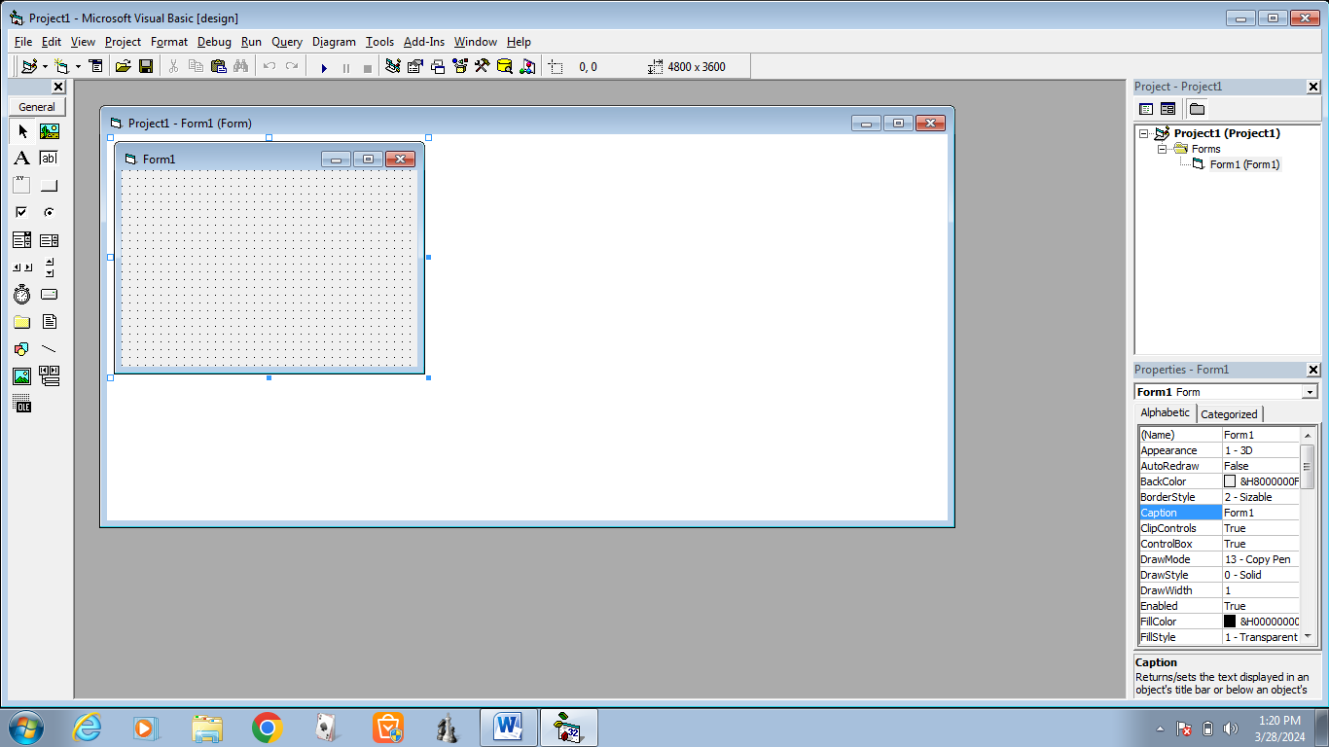

The Visual basic programming language is not unique to visual basic. Visual basic programming system, application system included in Microsoft Excel, Microsoft access and many other windows applications used the same language. The visual basic scripting edition (VB SCRIPT) is a widely used Scripting language and a subset of visual basic language.

**VISUAL BASIC EDITION**

Visual basic is available in three versions, each gear to meet a specific set of development requirements.

* Visual Basic learning edition allows programmers to easily create powerful applications for Microsoft Windows and Windows NT. It includes all intrinsic controls, plus grid, tab and data bound controls.
* The professional edition provides computer professional with full future set of tools for developing solutions for others. It includes all the features of leading edition, plus additional active x controls, the internet information server applications designer, integrated visual data base tools and data environments, active data objects and dynamic **HTML** pages designers.
* The enterprise edition allows professionals to create robust distributed applications in team settings. It includes all the features of the professional edition, plus back-office tools such as **SQL-SERVER**, visual source safe, **SNA** server and more

**VISUAL BASIC CONCEPTS**

In order to understand the application development process, it is helpful to understand some of the key concepts upon which visual basic is built. Because Visual Basic is a windows development language, some familiarity with windows environment is necessary.

**VISUAL BASIC REQUIRES**

Pentium processor with **MS-WINDOWS 7**. A compile installation of visual basic 6.0. Enterprise edition. Requires more than 100MB of hard disk space.

Visual basic consists of a customizable window that is the heart of every Microsoft Windows. All the controls exceptthe picture are object in visual basic. Their objects have associated properties, method and events programming object are loaded with properties.

A property is a named attribute of a programming object. Properties define the characters of an object such as size, colour, etc., or sometimes the way in which it behaves.

A method is an action that can be performed an object. A method is a connected or built-in procedure, a block of code that can be invoked to impact some action of a particular object. A method requires an object to given them a context. Visual basic programs are built basic, we work with project is a collection of that can be used to build an application writing a visual basic program invoked two steps,

1.Visual programming step

2.Code program

A visual programming involves designing an application with various tools that come alone with visual basic package. The code-programming step involves writing programming using text editor. Before writing the programs, we review specification.

**ADVANCE PROGRAMMING TOOLS**

**Multiple document interface**

A multiple document interface is used for opening many windows at the same time. The MDI can be designed for the document-centred application. This application allows the user to open many similar documents at the sometime. To create a document centred application in.

Visual basic, it needs at least two forms avoid from visual basic application can have only one MDI form, which contains all child form in a project.

A child form is an ordinary form that has its child property to true. Child form is displayed within the internal area of an MDI form at runtime.

**DAO** enables your client application to access and manipulate data in a database server through any of the **OLE DB** provides. According to Microsoft, **“**DAO’s primary benefits are ease of use, high speed, low memory over heads, and a small disk foot print. **DAO** supports key feature for building client/server and web-based applications”.

The **DAO** features an object model like the **DAO** and **RDO** but it is much flatter. In the case of the **DAO,** you had seventeen objects. In the case of the **DAO,** you have only seven objects. Besides, you do not have to follow a strict hierarchy when working with objects. For example, in the **DAO** you cannot create a record set without using the database objects, unlike in the case of **ADO**.

Let us see how the **ADO** allows you to access data from a database. Regardless of the data access method, working on the data from a database involves the following steps: The **ADO** programming model illustrated below allows you do all this and more.

**CONNECTION**

**COMMAND**

**PARAMETERS**

**RECORDSET**

**FIELDS**

**Data Access Objects (DAO)**

**DAO** enables us to use a programming language to access and manipulate data in local or remote database and to manage databases, their objects and structure.

**DAO** is suited best for either single system application or small, local deployments. Commonly used in conjunction with **PRIMARY KEY** constraints to serve as the unique row identifier for the table.

**FEATURES OF VISUAL BASIC 6.0:**

* Visual basic is the most productive tool for creating high performance enterprise and web-based applications.
* New features are gained in visual basic for tem development and scalability with the following:

1. Microsoft visual source safe 6.0
2. Visual modeler
3. Microsoft SQL-server 6.5 developer edition
4. Microsoft transaction server
5. Microsoft internet information server
6. Microsoft Queue server

Command object with drag and drop functionalities. Bind to multiple data sources for data aggregation and manipulation. Data report designer can quickly drag and drop custom data bound controls to create forms or reports.

1. Establishment of a connection to a data source.
2. Extraction of the required data with a suitable command.
3. Having extracted the data and worked on it we may have to update the data source.
4. Keep an eye on the errors that may occur and take suitable action.

**4.2 MICROSOFT ACCESS**

Microsoft Access 2007 is a DBMS package from Microsoft. It is one of the products in the Microsoft Office 2007 suite. This package is extensively used for building database application. The latest version of Access 2007 provides a plethora of new features designed to help us use the internet and develop World Wide Web application.

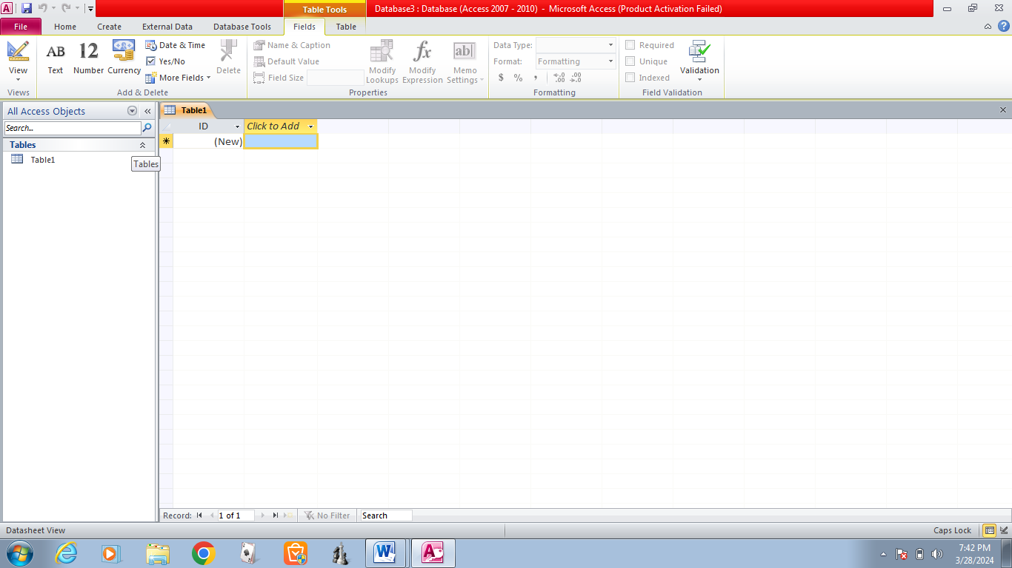

**DATABASE**

A Database is a collection of data stored in different objects such as tables, queries, forms etc.

**TABLES**

Tables are database objects created to store data. The tables can be created in many ways such as using a database view, design view, table wizard etc. Tables can also be imported from other databases and we can also link to tables of other databases.

**PRIMARY KEY**

For any tables, a primary key has to be set. It is a field that uniquely identifies each record. Assigning a primary key to a field ensures that no two records in the table have the same value in the field that defines the primary key. Primary key allows records to be stored by the entries in the primary key field. This also speeds up processing. We can either allow access itself to set a primary key for necessary field or we can set in manually.

**RELATIONSHIP BETWEEN TABLES**

When a table contains too many fields, it can be split up into two or more tables. These tables will be related to each other by a common field. for example, an employee

Table (containing the name and roll- no of the employee) will be related to the leave table (which contains all the leave details of employee) through the roll-no field

We can table also defines referential integrity relationships between tables when joining them. Referential integrity ensures that the relationship between records in related tables remain valid and can prevent problems from occurring, when a record that is related to records in another table is to be deleted or changed.

**CHAPTER-5**

**SYSTEM DESCRIPTION**

**5.1 EXISTING SYSTEM**

In the existing system all processing are done manually. Voluminous registers are maintained in which all information is stored. It suffers from the serious raw backs including the laborious task involved every time during the sales process, inaccuracy arising out of manual work and retrieving information requires lot of register reference and provide ambiguity

**EXISTING SYSTEM-DRAWBACK**

The existing system was run under the FoxPro package the following points necessities the new software.

* The existing system used array concept for the storage of values and calculation so, the maximum number of data that can be given to the program is fixed and if leads to wastage of memory.
* As the software doesn’t provide good user interface. No facility is available for the usage of mouse.

**5.2 PROPOSED SYSTEM**

**OBJECTIVES**

With the continued growth of the work force as with the growth with garments, the existing system is found to be insufficient to meet the user requirements. The main objectives of the developed system is to keep in pace with continue of growth of the work force for the growth of the garments, to automate the whole process and to upgrade the technology to keep abreast with the technical elevation of other modules and system

**THE OBJECTIVE INCLUDES**

* Production efficiency is supported by the new system. The system will cut down the manual validation
* The system will be integrated with other subsystems and utilize the data available in their interface modules effectively and reduce the time spent on generating the transaction and facilities easy access to the belonging subsystems.
* The system will eliminate duplicates data entry and help in better planning as there will not be any redundancy of data and hence it will eliminate any inconsistency, which grip in.
* It will in saving of time as well as operational cost for the company as the system will completely eliminate manual intervention and the time to get the result to any specific query will be reduced considerably.
* The system will be designed to the flexible enough to cater to the needs of the changes in the company policies and future requirements without much maintenance work.
* The system will cater to the change of the production components in terms of value, calculation methods at any time as well as the addition or deletion of any of the production components. Perceived benefits of the system

**CHAPTER 6**

**SYSTEM TESTING**

**UNIT TESTING**

Instead of testing the system as a whole, unit testing focuses of the modules that make up the system. Each module is taken up individually and tested for correctness in coding and login. Error resulting from interaction of modules is initially avoided.

**INTEGRATED TESTING**

It tests for the error resulting from integration of modules. One specification of integration testing is the interface weather parameters match on both sides of type permissible range and meaning. Analysts try to find areas different specification for data element. Integration testing is functional of black box testing method. That is using testing, each module is treats as an impenetrable mechanism for information a mechanism. The only concern during integration testing is that the modules work together property.

**PROGRAMMING TESTING**

The main aim is it achieves an error-free program. A program represents the; logical element of the system. Program testing checks for two types of error ; syntax and logic. A syntax error is a program statement that validates one or more rules of the language in which it is written. A logic error deals with incorrect data fields, out of range items, and invalid combinations. When a program is tested, the actual output is compared with expected output. If both match than it is error free program.

**WHITE BOX (Code testing)**

The main testing strategy examines the logic of the program. To follow this testing method, the analyst develops test cases that result in executing every instruction in the program or module in every path through the program is tested. A path is a specific combination of conditions that is handled by the program. Code testing also not check the range of data that program will accept, even though, when software failures occur in actual use, it submitted data outside of expected ranges.

**BLACK BOX (Specification testing)**

To perform specification testing, the analyst examines the specification starting what the program should do and how it should perform under various condition. Then test cases are developed for each condition or combinations of conditions and submitted for processing. By examining the result, the analyst can determine whether the programs perform according to its specified requirement. This testing strategy on the face of it sounds exhaustive. If every statement in the program is checked for its validity, their doesn’t seem to be much for errors.

**CHAPTER-7**

**SYSTEM IMPLEMENTATION**

The term implementation has different meaning, ranging from the conversion of a basic application to complete replacement of a computer system. The procedure, however, is virtually the same. Implementation is used here to mean the process of converting a new or revised system design into an operational one. Conversion is one aspect of implementation. The order aspects are the post implementation review and software maintenance.

**CHAPTER-8**

**SYSTEM SECURITY**

**INTRODUCTION**

Howard A. Schmidt, ISSA President, has been appointed Vice Chair of the President’s Critical Infrastructure Protection Board. Howard will join Disk Clarke’s Cyberspace Security team in the White House near the end of the month, reporting to Condoleezza rice, Nation Security Advisor and Gov. Tom Ridge, Director of Homeland security. Howard will be involved in building a specialized government and private sector leaders to focus on homeland cyber security. Almost in all the organization the marketing personal information and result Market Projections of data must be kept secret to function the organization in a good manner so system security must be provided to avoid the less of data accessing of data by authorized persons.

**PASSWORD SETTING**

A password is in encrypted format. A password is given for the new system. The access rights are provided to users entering the correct password. The password must be changed periodically.

**BACKUP AND RECOVERY**

Backup and recovery is user during the loss of or damaged data. For that the table structures are converted onto text and table values are converted into database file and text file.

**CHAPTER-9**

**FUTURE ENHANCEMENT**

The current system has vital improvement an area which when makes it a completed system makes it a complete system. The key domains which when enhanced from the newly implemented system make it a complete system.

* The system was developed in visual basic.
* To make the user easier to interact we have created the project in visual basic. We can also implement the system in LAN environment to make the system available for more than one user.
* To bring this application into internet for using different branches in the same company and getting orders from internet.
* To bring this information into mobile for getting order through mobile devices
* To bring business to customer concept in near future.

**CHAPTER-10**

**APPENDIX**

**10.1 SAMPLE SOURCE CODE**

**10.1.1 MAIN MODULES**

**Private Sub Command1_Click ()**

Form4.Show

Me.Hide

**End Sub**

**Private Sub Command2_Click ()**

Form14.Show

Me.Hide

End Sub

**Private Sub Command3_Click ()**

**Form15.Show**

Me.Hide

End Sub

**Private Sub Command4_Click ()**

Form10.Show

Me.Hide

**End Sub**

**Private Sub Command5_Click ()**

Form11.Show

Me.Hide

**End Sub**

**Private Sub Command6_Click** ()

Form12.Show

Me.Hide

**End Sub**

**Private Sub Command7_Click ()**

Form22.Show

Me.Hide

**End Sub**

**10.1.2 DASHBOARD**

**Private Sub Command1_Click()**

Form5.Show

Me.Hide

End Sub

**Private Sub Command2_Click ()**

Form6.Show

Me.Hide

**End Sub**

**Private Sub Command3_Click ()**

Form7.Show

Me.Hide

**End Sub**

**Private Sub Command4_Click ()**

Form3.Show

Me.Hide

**End Sub**

**Employee Leave Applications**

**Private Sub Command1_Click()**

MsgBox ("Are you sure want to delete it")

Data1.Recordset. Delete

**End Sub**

**Private Sub Command2_Click()**

Form4.Show

Me.Hide

**End Sub**

**Private Sub Command3_Click()**

Data1.Recordset. AddNew

**End Sub**

**Private Sub Command4_Click()**

Data1.Recordset.Update

**End Sub**

**Internal Job Postings**

**Private Sub Command1_Click()**

Form5.Show

Me.Hide

**End Sub**

**Private Sub Command2_Click()**

Form6.Show

Me.Hide

**End Sub**

**Private Sub Command3_Click()**

Form7.Show

Me.Hide

**End Sub**

**Private Sub Command4_Click()**

Form3.Show

Me.Hide

**End Sub**

**Internal Job Applications**

**Private Sub Command1_Click()**

Data1.Recordset. Delete

**End Sub**

**Private Sub Command2_Click()**

Data1.Recordset.AddNew

**End Sub**

**Private Sub Command3_Click()**

Data1.Recordset.Update

**End Sub**

**Private Sub Command8_Click()**

Form4.Show

Me.Hide

**End Sub**

**10.1.3 EMPLOYEE INFORMATION**

**Private Sub Command1_Click()**

Form8.Show

Me.Hide

**End Sub**

**Private Sub Command2_Click()**

Form16.Show

Me.Hide

**End Sub**

**Private Sub Command3_Click()**

Form17.Show

Me.Hide

**End Sub**

**Private Sub Command4_Click()**

Form3.Show

Me.Hide

**End Sub**

**Private Sub Command5_Click()**

Form9.Show

Me.Hide

**End Sub**

**Employee Basic Information**

**Private Sub Command1_Click()**

Data1.Recordset.AddNew

**End Sub**

**Private Sub Command2_Click()**

Form9.Show

Me.Hide

**End Sub**

**Private Sub Command3_Click()**

Form15.Show

Me.Hide

**End Sub**

**Private Sub Command4_Click()**

Data1.Recordset.Update

**End Sub**

**Employee Educational Background**

**Private Sub Command1_Click()**

Data1.Recordset.Edit

**End Sub**

**Private Sub Command2_Click()**

Form15.Show

Me.Hide

**End Sub**

**Private Sub Command3_Click()**

Data1.Recordset.AddNew

**End Sub**

**Private Sub Command4_Click()**

Data1.Recordset.Update

**End Sub**

**Employee Bank Details**

**Private Sub Command4_Click()**

Form15.Show

Me.Hide

**End Sub**

**Employee Last Work Experience**

**Private Sub Command2_Click ()**

Form15.Show

Me.Hide

**End Sub**

**10.1.4 SALARY MANAGEMENT**

**Private Sub Command1_Click()**

MsgBox (" Are you sure want to edit salary ?")

Data1.Recordset.Update

**End Sub**

**Private Sub Command2_Click()**

Form3.Show

Me.Hide

**End Sub**

**Private Sub Command3_Click()**

Data1.Recordset.Edit

**End Sub**

**10.1.5 ATTENDANCE MANAGEMENT**

**Private Sub Command1_Click ()**

Data1.Recordset. Edit

**End Sub**

**Private Sub Command2_Click ()**

Form3.Show

Me.Hide

**End Sub**

**10.1.6 REPORTS**

**Private Sub Command1_Click()**

Form13.Show

Me.Hide

**End Sub**

**Private Sub Command2_Click()**

Form3.Show

Me.Hide

**End Sub**

**Private Sub Command3_Click()**

Form21.Show

Me.Hide

**End Sub**

**Private Sub Command4_Click()**

Form34.Show

Me.Hide

**End Sub**

**Payroll Report**

**Private Sub Command2_Click()**

Form12.Show

Me.Hide

**End Sub**

**Leave Report**

**Private Sub Command2_Click()**

Form12.Show

Me.Hide

**End Sub**

**Employees info**

**Private Sub Command2_Click ()**

Form12.Show

Me.Hide

**End Sub**

**10.2 SCREENSHOTS**

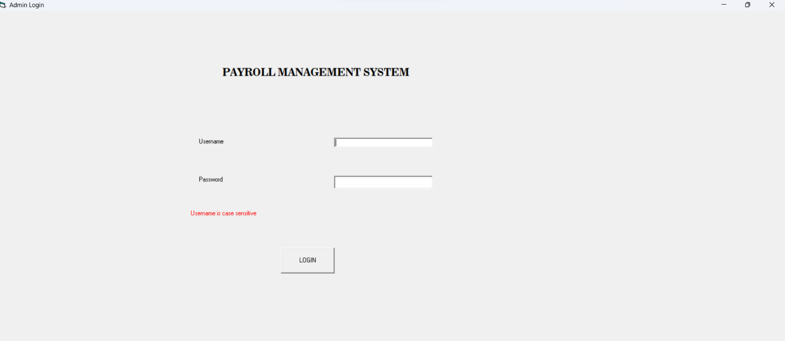**10.2.1 Login Screen**

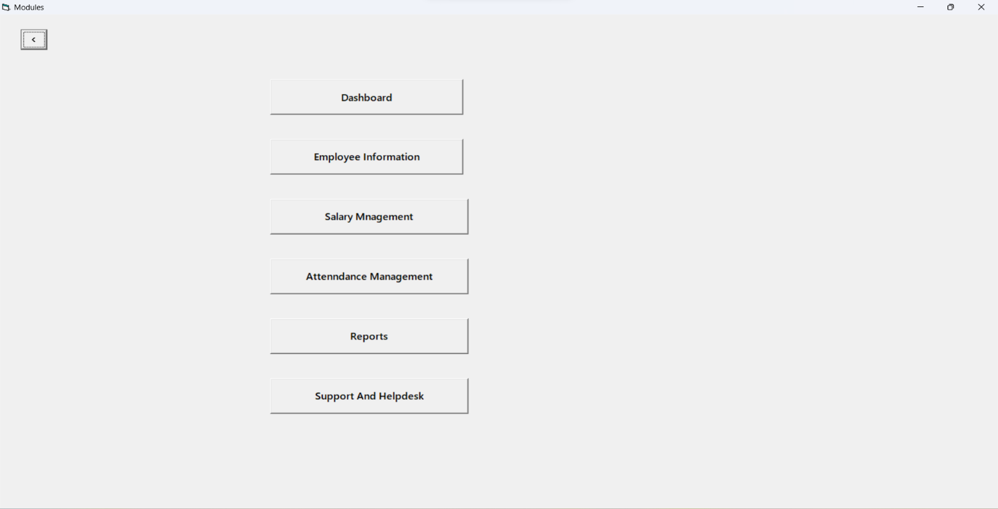**10.2.2 Modules**

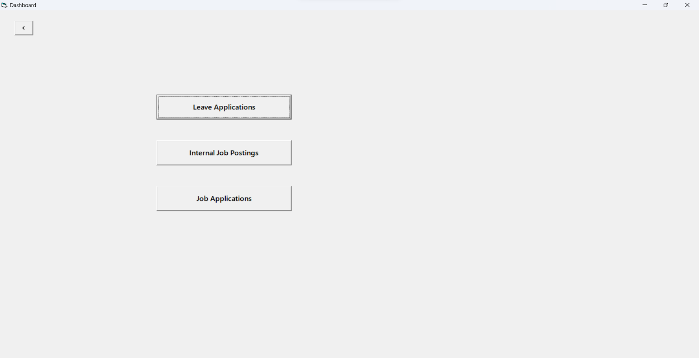**10.2.3 Dashboard**

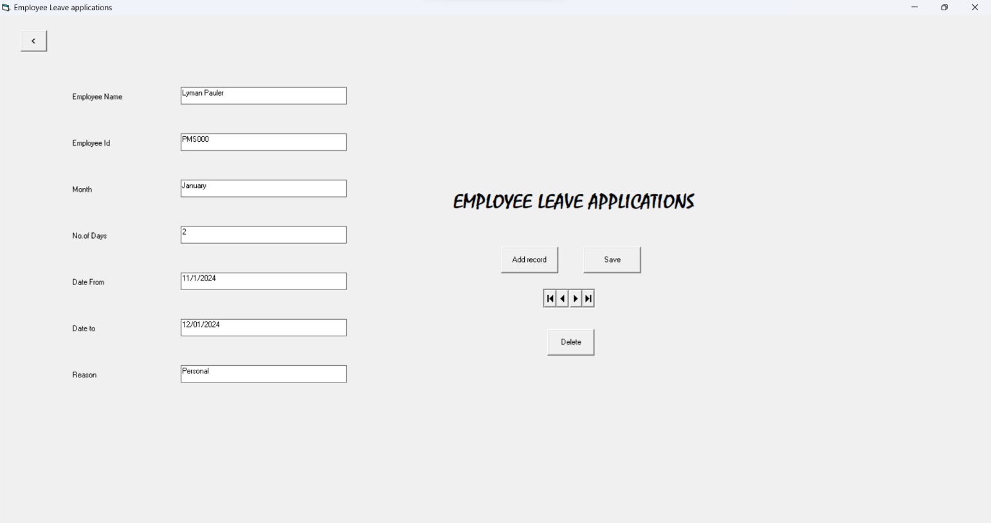**10.2.4 Leave applications**

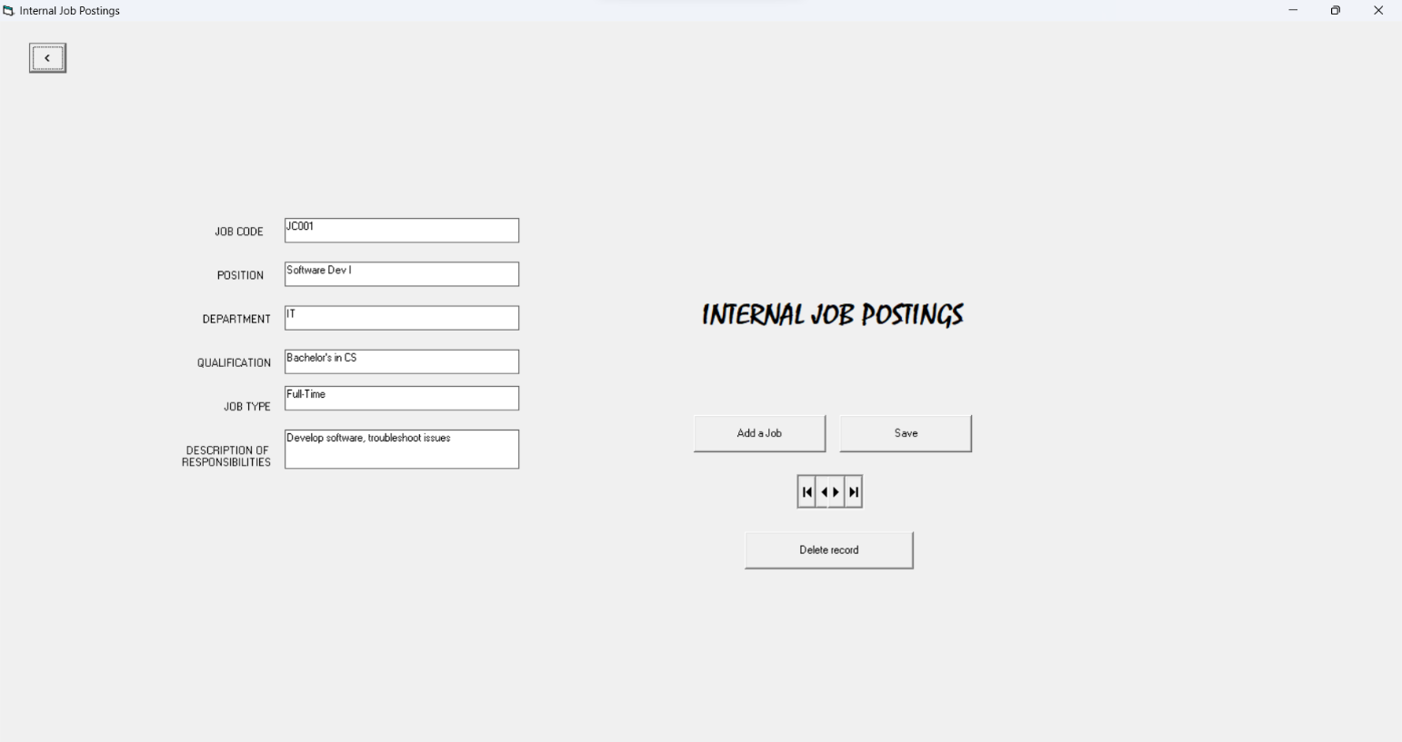**10.2.5 Internal job postings**

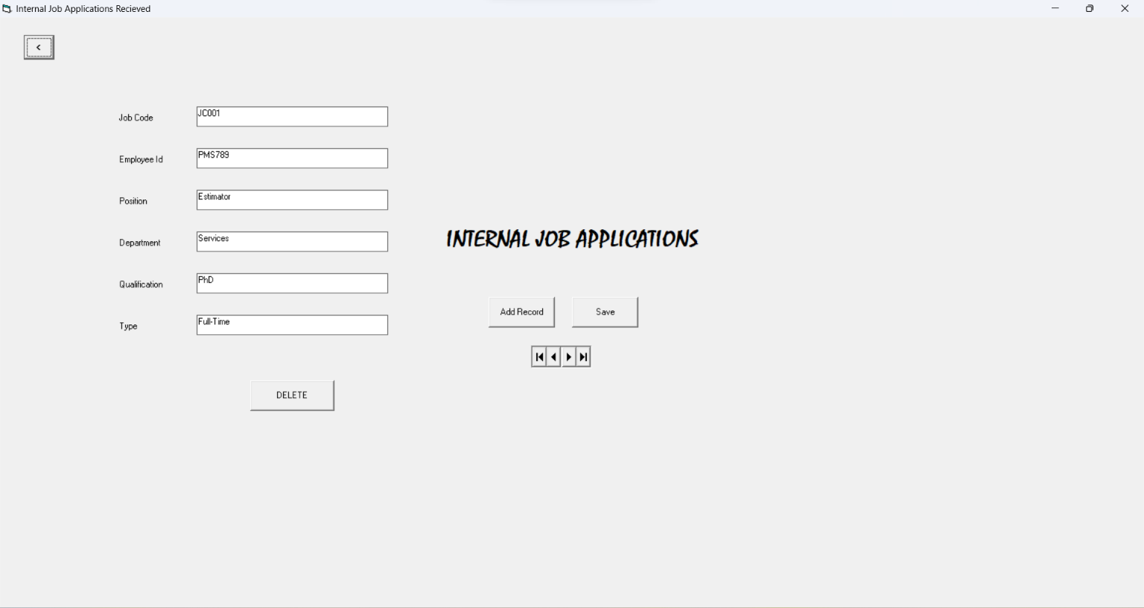**10.2.6 Job applications**

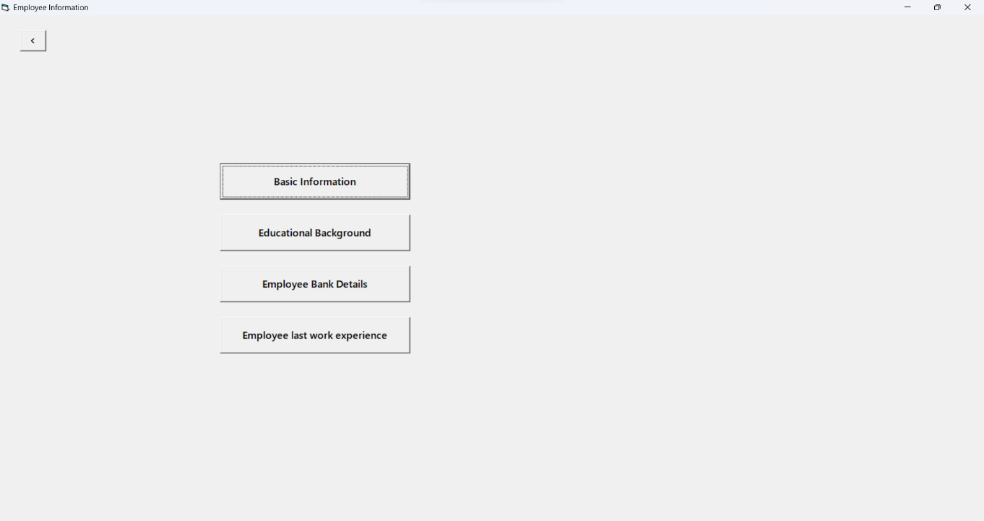**10.2.7 Employee information**

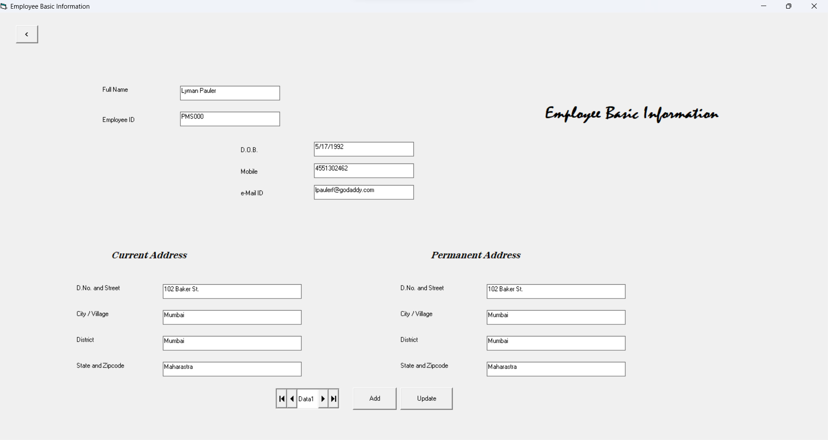**10.2.8 Basic information**

**10.2.9 Salary Management**

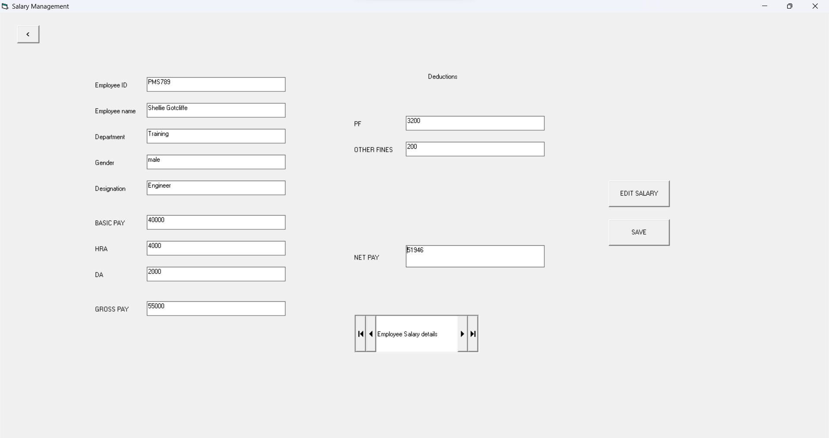

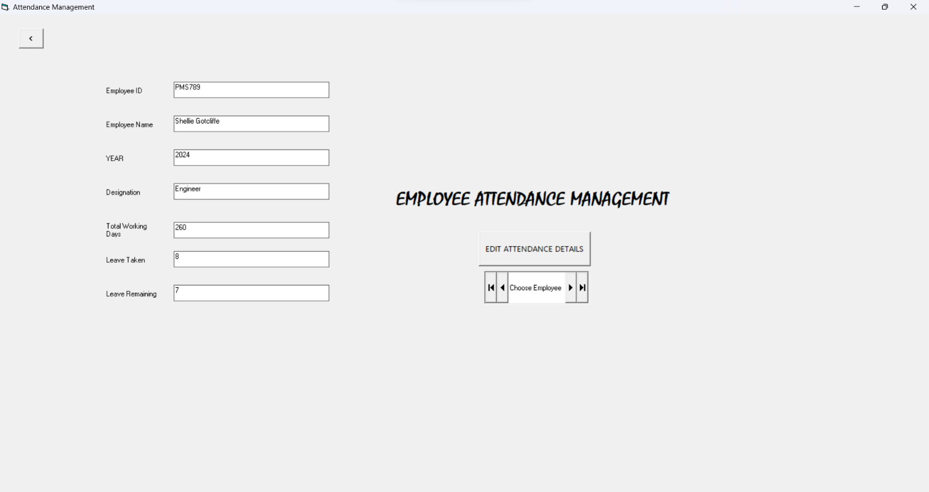**10.2.10 Attendance management**

**10.2.11 Reports**

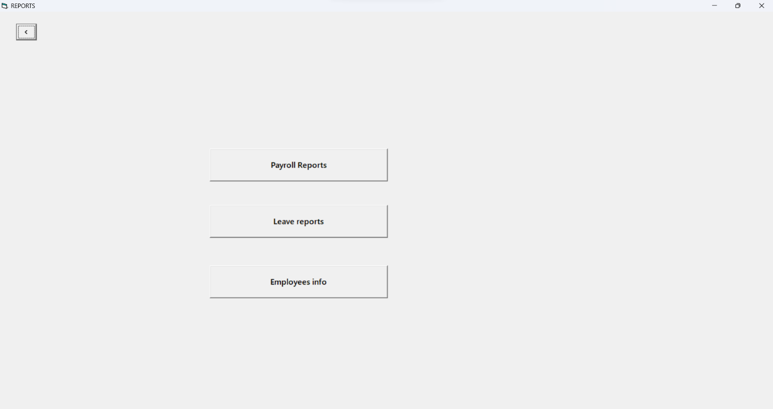

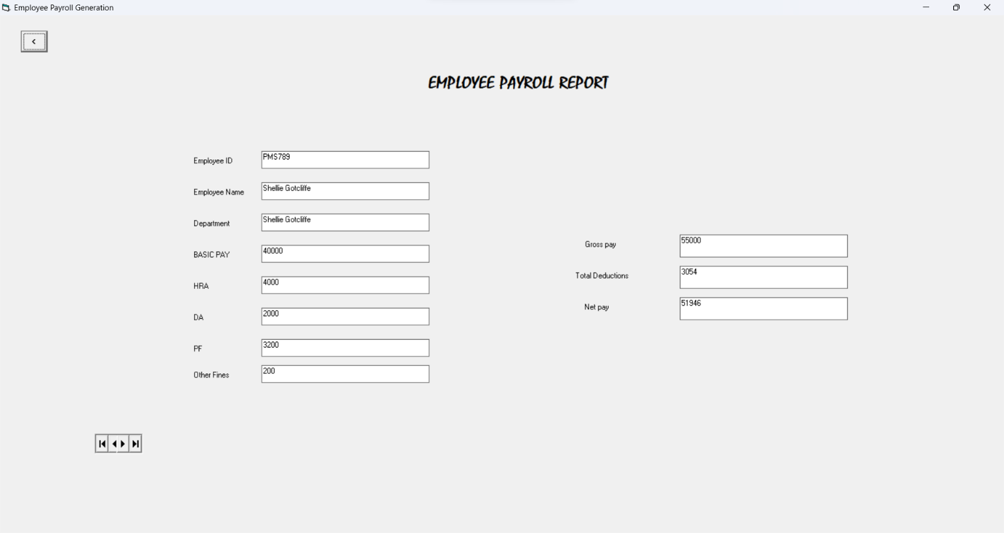**10.2.12 Employee Payroll report**

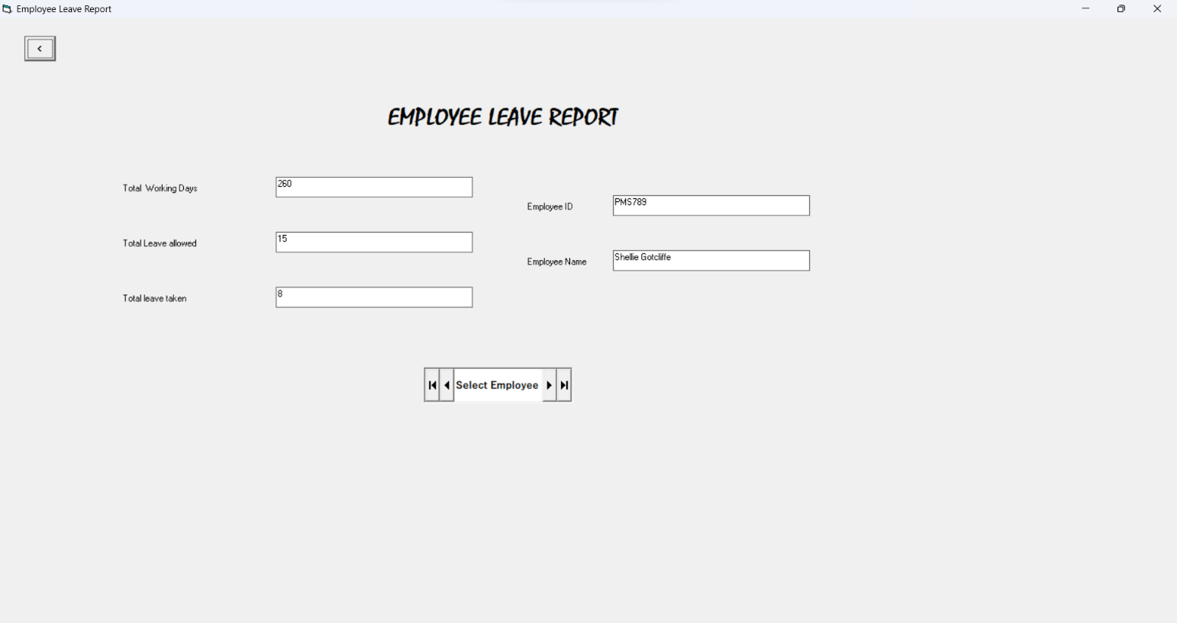**10.2.13 Employee leave report**

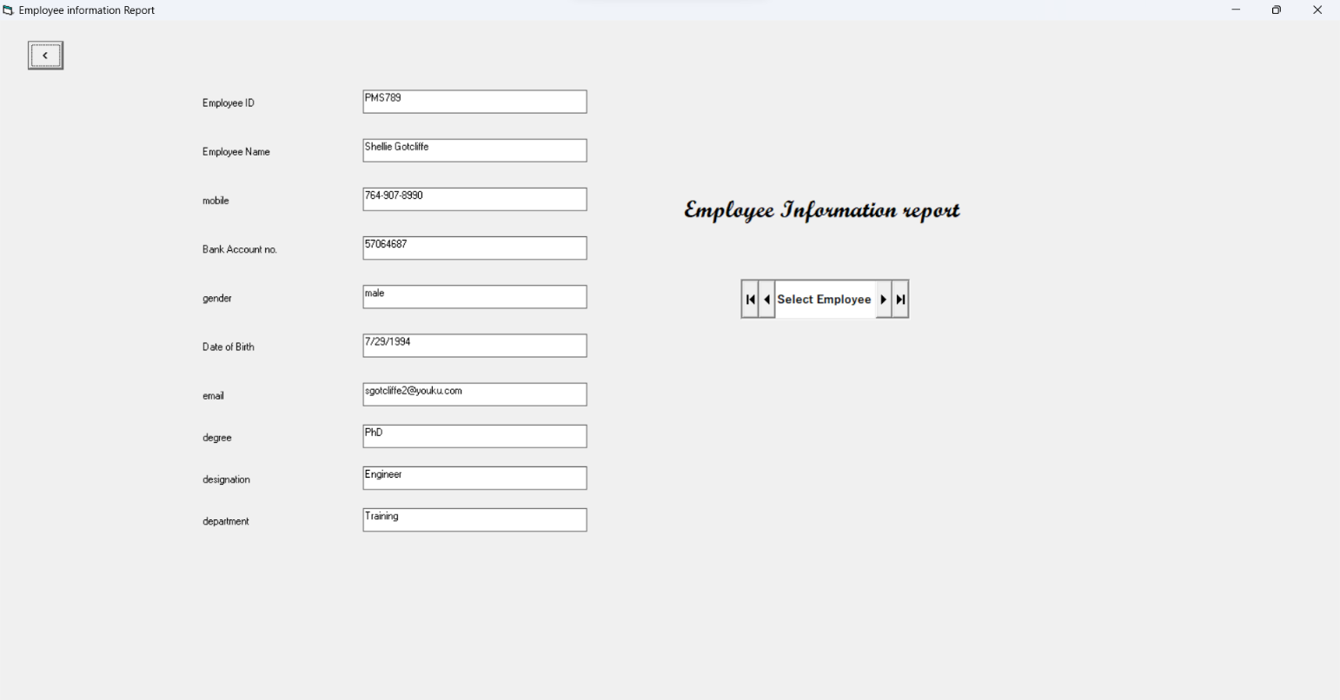**10.2.14 Employees info**

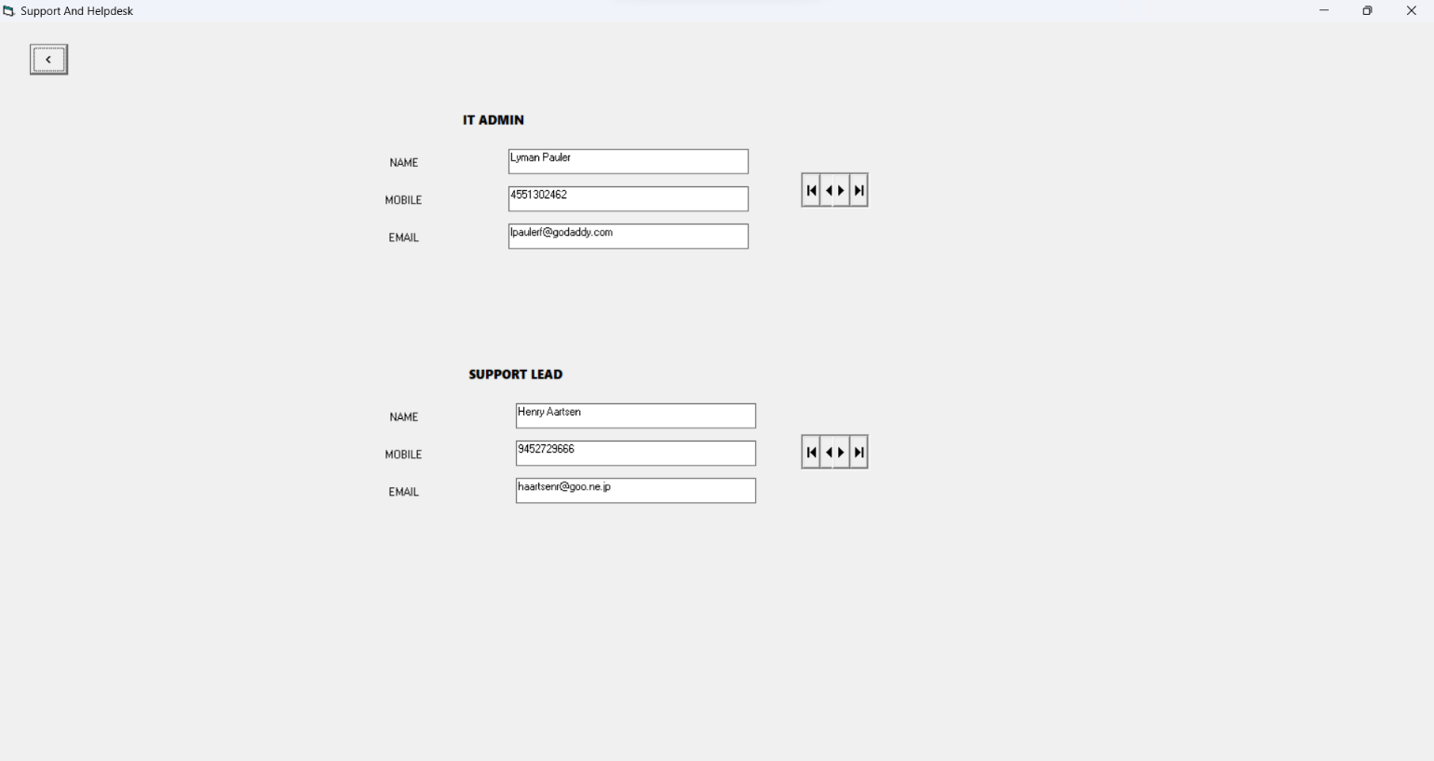**10.2.15 Support and helpdesk**

**CHAPTER-11**

**CONCLUSION**

The **PAYROLL MANAGEMENT SYSTEM** was designed to meet requirement of the HR for handling employee details for all. It is error free and makes the user to retrieve the data immediately.

The project was aimed at this and it is successfully achieved with in the limited time period. Multiple reports are generated to facility and the entire system is perfectly machine current manual system. It requires accuracy and fast result.